**Name: Jeet Thakkar**

**TryHackMe Neighbour Lab**

**Difficulty: Begineer**

**Purpose Of Lab:** We have to follow the mentioned IP Adress which will take us to login page where we have to find guest login credentials from source code and then try to bypass the **IDOR vulnerability** and gain access as **Admin** and capture Neighbours flag.

**Task:1 Open The IP Adress:**

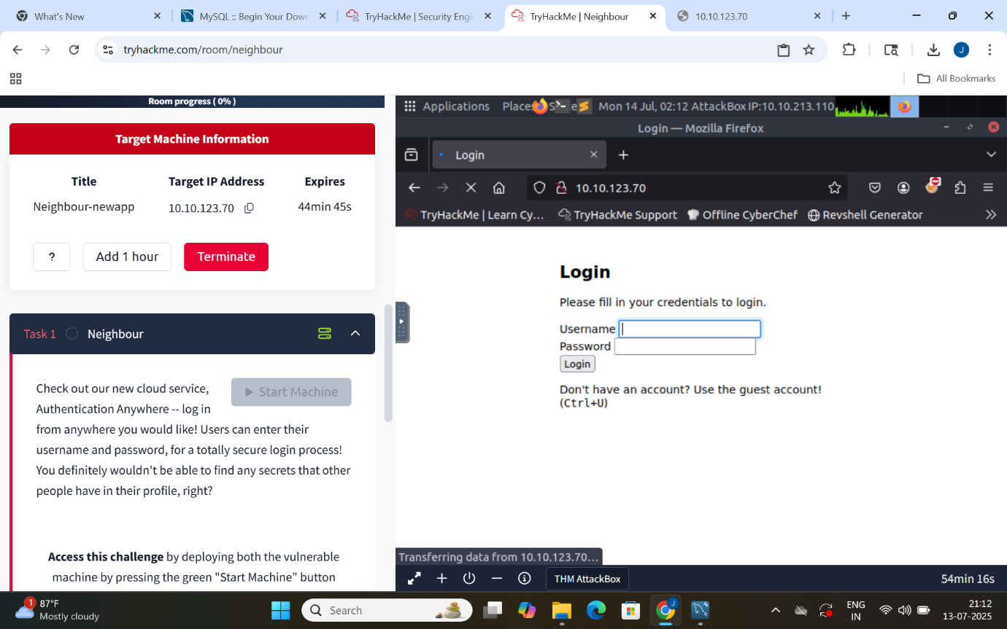

**Task:2 Open The Source Code: Ctrl+u**

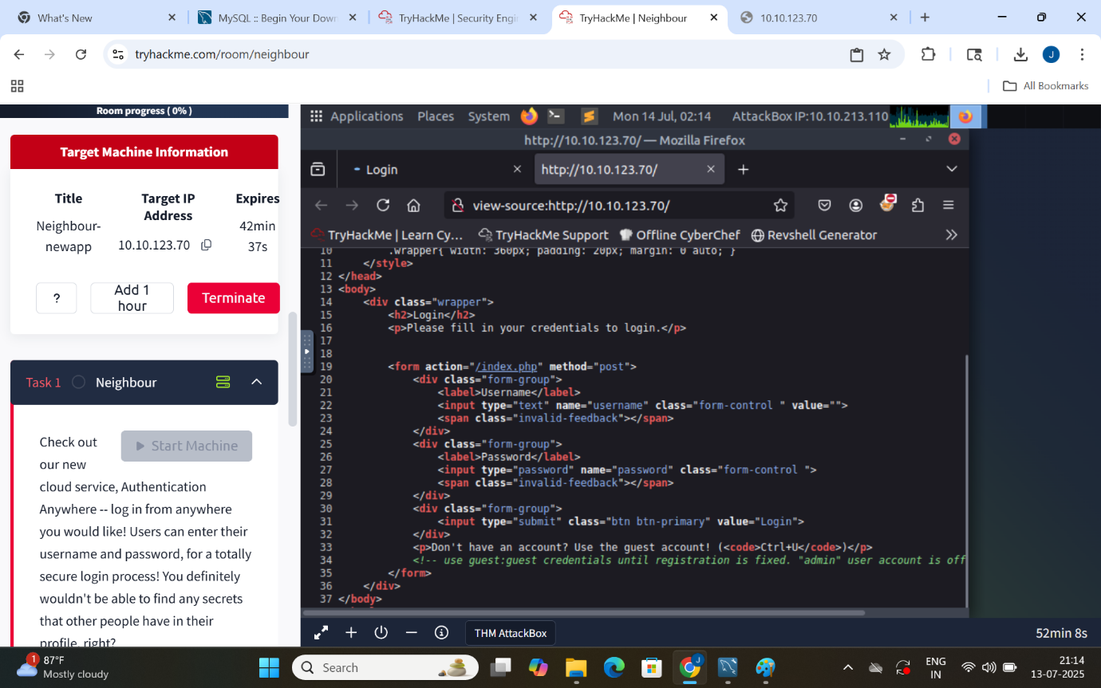

**Extract The Guest Login Credentials (guest,guest) Login Id, Password**

**Task:3 Login As Guest**

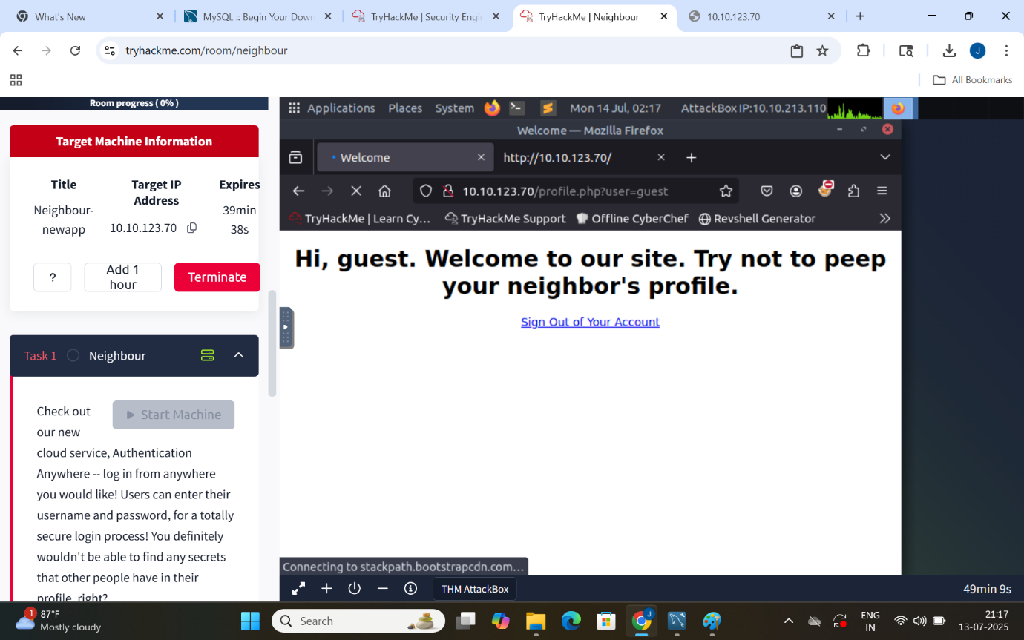

**Task:4 Gain Access Of Admin Account By Identifying IDOR And By Modifying user=guest to user=admin**

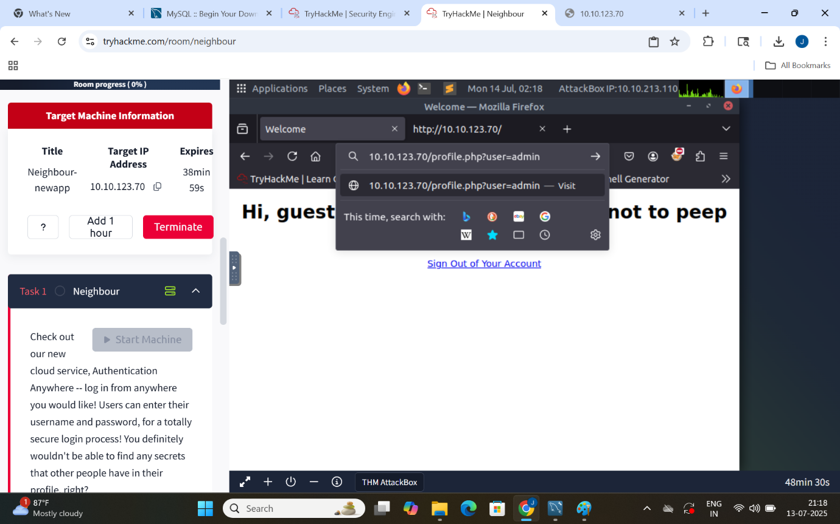

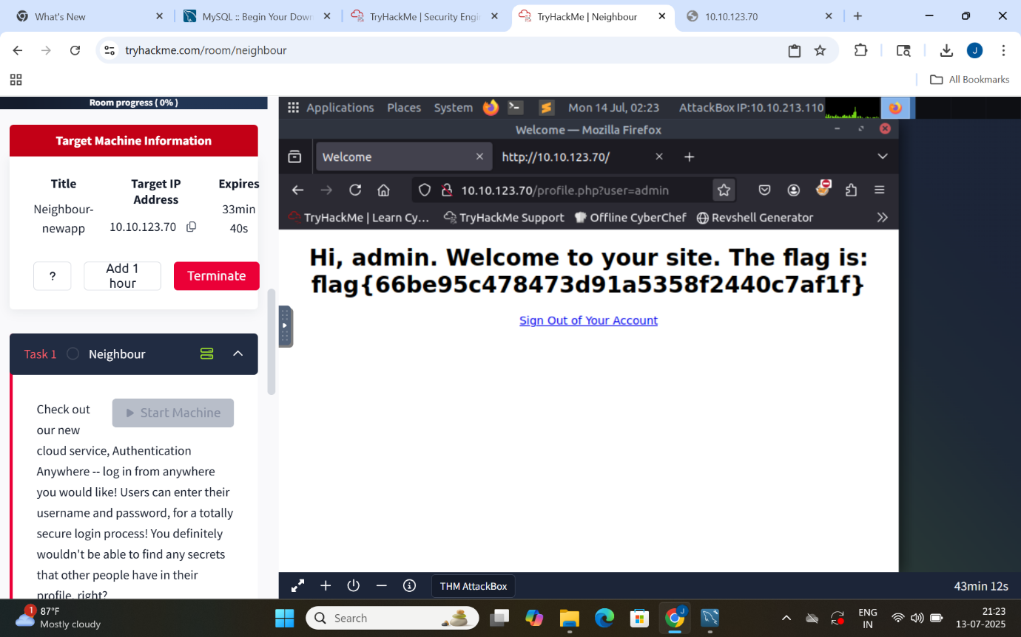

**Task:5 Claiming The Flag**

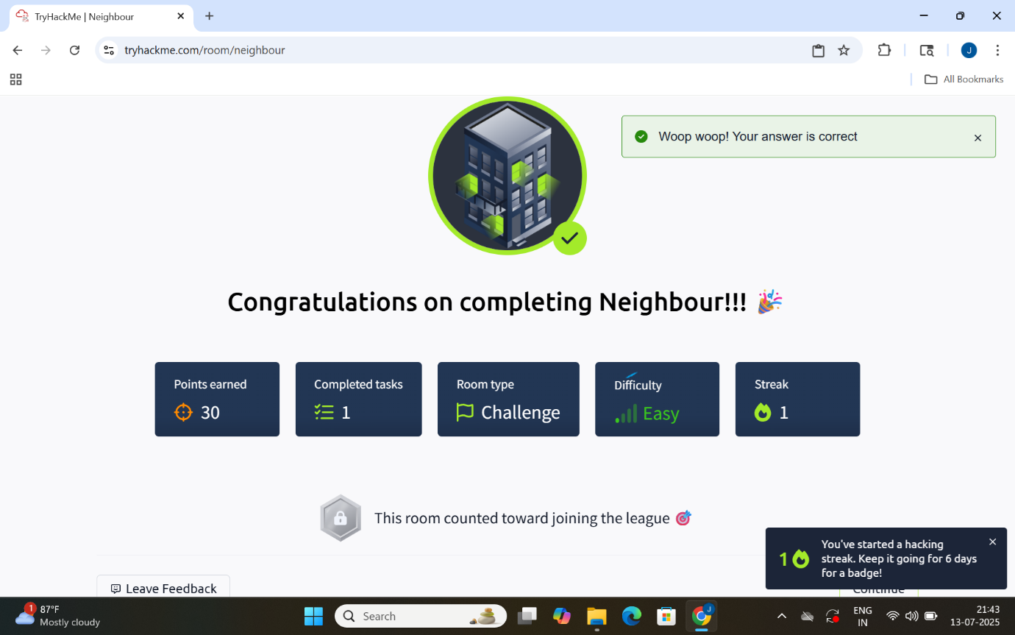

**Takeaways:**

**Neighbour – TryHackMe IDOR Exploit**

**## 🛡 What is IDOR?**

**Insecure Direct Object Reference allows attackers to access unauthorized data by modifying references in the URL or parameters.**

**## 🧪 Challenge Summary**

**- Logged in as guest using hidden credentials.**

**- Modified user=guest to user=admin in URL.**

**- Gained access to admin zone and retrieved the flag.**

**## 🧰 Tools Used**

**- Browser DevTools**

**- Python requests (optional automation)**

**## 📈 Learnings**

**- Real-world IDOR vulnerability demonstration**

**- Understanding of broken access control**

**- Importance of validation and authorization in every endpoint**

**## 🏛 Room Info**

**- Platform: TryHackMe**

**- Room: Neighbour**

**- Difficulty: Beginner**